**Tips for preventing birth defects**

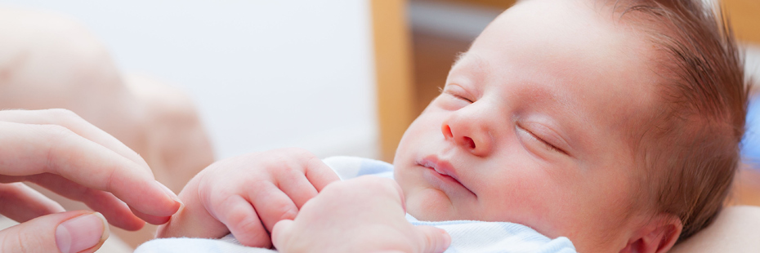Once you plan to conceive a baby, make sure you are ready. Adopt healthy eating habits and minimize intake of harmful substances. After all, you are going to support two lives for the next 9 months! Choose a healthy lifestyle, make an active routine and meet your specialist timely!

After taking all preventive measures, we can’t prevent some common birth defects causes. Certainly, there are some tips for preventing birth defects as soon as a lady becomes pregnant. We just need to follow them and know how to avoid birth defects. Though chances of having a baby with birth defects as very less if you are healthy but that’s how “Precaution is better than cure” works.

Don’t be afraid! Then, how to avoid birth defects? Prevent birth defects while pregnant! Just follow some tips for preventing birth defects and it will all be okay.

Here are some tips for preventing birth defects on how to avoid birth defects:

* **Plan your routine**

Take an appropriate quantity of folic acid every day. Women taking folic acid in diets or supplements give birth to healthier babies. Also, folic acid prevents various birth defects.

Tips for preventing birth defects include meeting your specialist as and when required. Fix your schedule and see your doctor regularly to avoid any complications that may pop up unexpectedly. Starting prenatal care is recommended when you are planning to get pregnant. Follow this along with other tips for preventing birth defects.

* **Push ‘harmful substances’ aside**

There are several habits practised by a woman that can harm her baby during pregnancy. The tips for preventing birth defects include the exclusion of smoke, alcohol and drugs from the routine.

Alcohol in the bloodstream goes through the umbilical cord. It may affect a baby’s growth or cause infection. Quit smoking during pregnancy! Any kind of drug will directly cause harm to the unborn baby. Therefore, to follow tips for preventing birth defects is mandatory to protect your child.

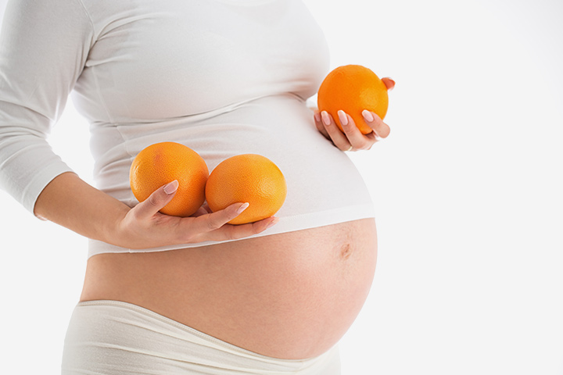

* **Folic acid makes it better**

Folic acid is an important nutrient that prevents birth defects causes related to the spine and brain. But, how does folic acid prevent birth defects? Almost 70% of the neural tube defects can be prevented by your folic acid intake amount. Also, choose between several tips for preventing birth defects that suits your body. A balanced diet with a balanced intake of folic acid decreases the chances of having a baby with birth defects.

* **Choose a healthy lifestyle**

If you are already suffering from a disease, make sure the situation is under control. Increasing the level of disease increases the chances of having a baby with birth defects. With common birth defects, it can bring complications in the pregnancy.

Several tips for preventing birth defects also include maintaining a healthy lifestyle. Try to maintain a normal body weight before pregnancy and choose to stay as fit as possible.

* **Never miss appointments**

Seeing the doctor tops the list of tips for preventing birth defects. Talk to your medical specialist regularly and share every minute changes you feel in your body. Some changes are generous while some might not be. To prevent birth defects while pregnancy, listen to your specialist and follow her.

**Foods that cause birth defects**

A developing baby has different nutritional needs than a grown-up. Therefore, a diet nurturing you and your baby in the right amount is necessary. Especially, when there are various foods that cause birth defects during pregnancy.

* **Minimize or simply avoid foods with infection risks**

The diet is not limited to fruits and vegetables, but certain eateries need to be removed from the diet to make it healthy. A woman takes care of two lives during pregnancy. Subsequently, she has to choose and eat food suitable for both. And therefore, foods that cause birth defects must be avoided.

This category includes **uncooked seafood, smoked seafood, shellfish, undercooked meat, raw eggs**. Uncooked seafood carries coliform bacteria which is dangerous for a baby’s immune system. Certain bacteria are infectious too.

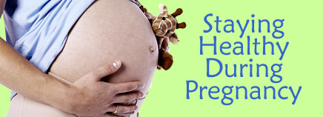Avoid dairy products like **unpasteurized milk, soft cheese** etc. and make it a habit to use products after washing. Unpasteurized milk may carry listeria, which is fatal for a baby in the womb. By avoiding these foods that cause birth defects, you avoid common birth defects causes too.

* **How does folic acid prevent birth defects?**

This adds in the tips for preventing birth defects because folic acid is the main ingredient to pregnancy. Folic acid is a source of B vitamin in our body that is required in sufficient amount for a going-to-be mother’s body i.e. 1mg daily.

If a woman has enough folic acid one month prior to or during pregnancy, birth defects like the brain and spinal cord disabilities are reduced. This show how does folic acid prevent birth defects.

**Test for birth defects during pregnancy**

Certain birth defects can be diagnosed during pregnancy, depending upon the type of birth defect. Tips for preventing birth defects include taking proper medical tests.

**Prenatal Testing**

1. **Screening Tests**

A screening test shows a rough picture of the baby in a mother’s womb. The test doesn’t give a specific diagnosis. It only gives a rough idea of how healthy a baby is during pregnancy. A screening test can give false tests. For example, it may show some defects in a healthy baby or it might not be able to display defects if there are any.

So, basically, the screening test is a primary test to know whether the young one is healthy or does he need extra care. There are two types of screening tests:

1. **First Trimester Screening**

This screening is done between 11th and 13th week of pregnancy. It combines the Maternal Blood Screen and Ultrasound. These tests test for birth defects during pregnancy.

* Maternal blood screen test is a blood test in which levels of proteins (human chorionic gonadotropin (HCG) and pregnancy-associated plasma protein A (PAPP-A)) are measured. If the proteins levels are abnormal, there are chances of a chromosomal disorder in the baby.
* Ultrasound looks for extra fluid present behind the neck that may cause chromosomal disorder or a heart defect. It is also a screen-based test.

1. **Second Trimester Screening**

These tests are scheduled between 15th and 20th weeks of pregnancy. It combines Maternal Serum Screen and Anomaly Ultrasound.

* Maternal Serum Screen is a simple blood test which tests for birth defects during pregnancy such as neural tube defects or Down syndrome (a chromosomal disorder). It checks multiple protein levels. The tests are named accordingly. For example, a quad screen tests levels of 4 proteins (hCG, estriol, alpha-fetoprotein, inhibin-A).
* Anomaly Ultrasound- In simple terms, an ultrasound displays a 2-D image of the baby on the screen. Generally, it is supposed to be completed during 18-20 weeks of pregnancy. This test checks the size of the baby and hence looks for birth defects causes if any.

1. **Diagnostic Test**

Common birth defects are visible in screening tests. If screening tests give abnormal reports, then doctors switch to Diagnostic tests to test for birth defects during pregnancy and to help a lady and prevent birth defects while pregnant.

Usually women with higher risks of pregnancy, women above 35 years of age or women suffering from chronic diseases such as high blood pressure, diabetes, lupus or women who use certain other medications.

Conclusion

Every woman rejoices in the moments of her pregnancy and carrying a life with her. Leaving worries behind, now you can easily prevent birth defects while pregnant. There are various methods available online that will feed your searching desire! Just go on exploring and before applying those tips, consult your caretaker once.